CS 233N: Lab 0, Part A NAME: Lucas Ruiz

Exercise 1 - Complete tutorial 6-1: Toggle Light
This exercise uses methods to show and hide picture boxes to give the illusion of turning a light bulb on and off. Visual Studio start files are on Moodle. Copy and paste screen prints of your methods here.
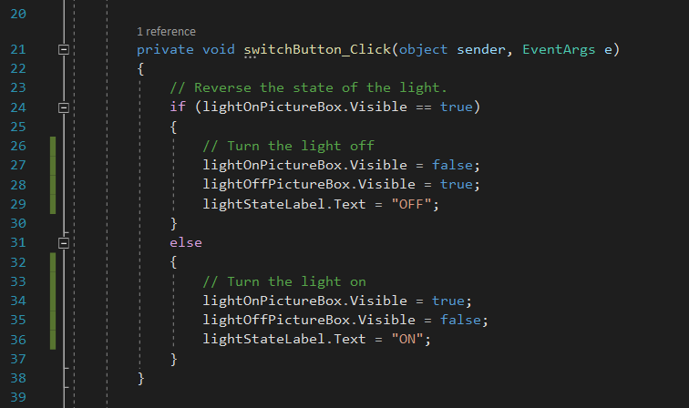

Exercise 2- Complete tutorial 6-2: Display Card
This exercise uses several methods. One method needs a string argument passed to it. The value of this argument is used to determine what method to call to display a specific picture box and hide the others. Visual Studio start files are provided on Moodle. Copy and paste screen prints of your methods here.
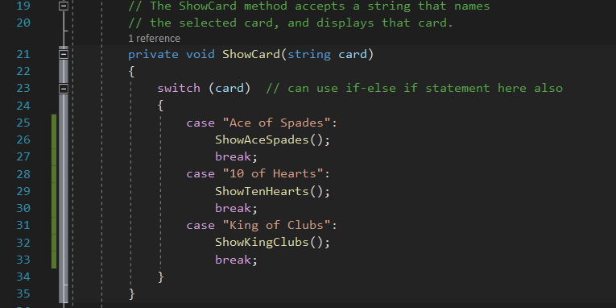
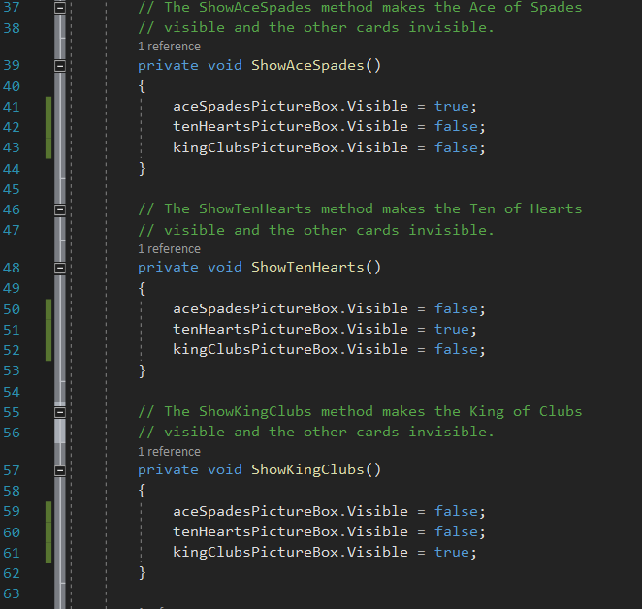

Exercise 3 - Complete tutorial 6-4: Cups to Ounces Conversion
This exercise uses a method to return the number of ounces given the number of cups. Visual Studio start files are provided on Moodle. Copy and paste screen prints of your methods here.
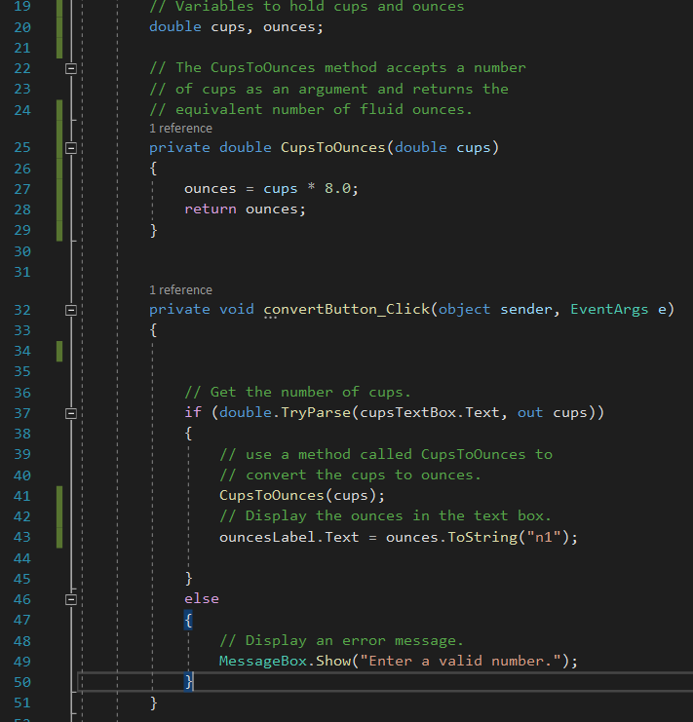

Exercise 4 - Kilogram Conversion
The conversion rate of kilograms to pounds is given by: 1 kilogram = 2.20462 pounds
Create a method that returns the number of pounds given the number of kilograms.
The conversion rate of pounds to ounces is given by: 1 pound = 16 ounces
Create a second method that returns the number of ounces given the number of pounds.

Your application should display a table of kilograms from 10 to 25 along with the equivalent number of pounds and ounces. Use a Load Event handler to display that information. A start project is provided on Moodle. Your output should look like the following.
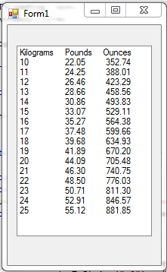

Copy and paste screen prints of your program code for exercise 4 here:
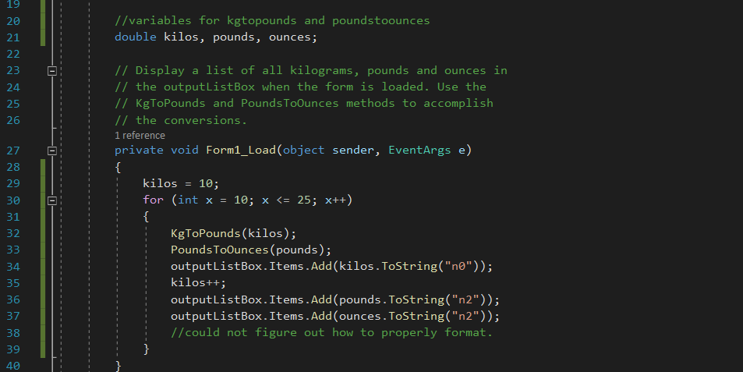
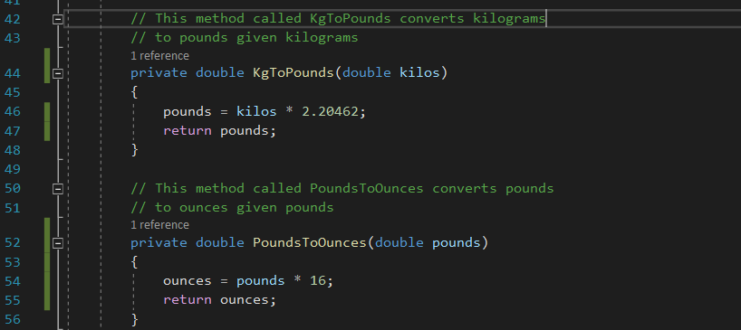

Upload this file to the proper link in Moodle. There is no need to submit pseudocode for this exercise.

